**ASSIGNMENT 5**

Question 1 )HashSet

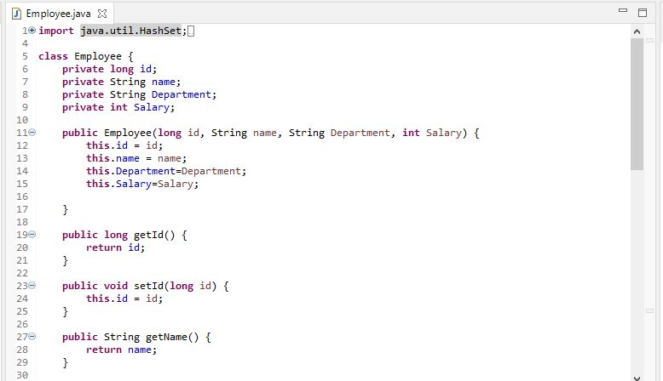

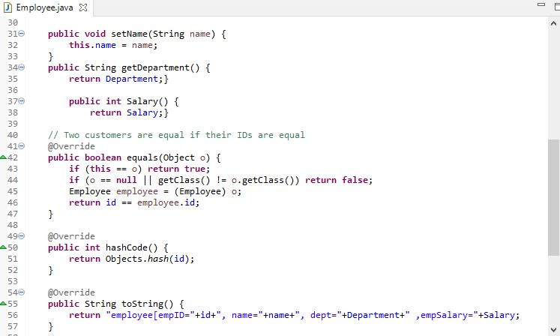

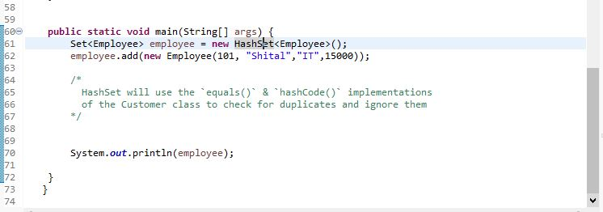

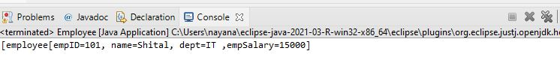

Q2) Hashmap

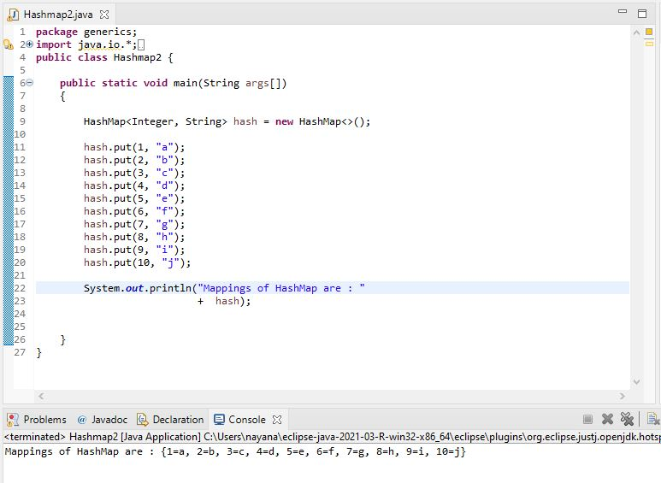

Q3)Generic method to exchange element in array

public final class Algorithm {

public static <T> void swap(T[] a, int i, int j) {

T temp = a[i];

a[i] = a[j];

a[j] = temp;

}

}

Q4)

Pair Class

